Full Name: BJ
Address: Flushing, NY
Date of Birth: 02/22/1941
Date & Time: March 18, 2022
Location: Trauma unit NYPQ ER
Source of Information: Medical records/common law husband
Reliability: reliable
Mode of Transport: Ambulance

HPI: 81yo F with pMHx of myelofibrosis, Waldestrom macroglobinemia, PE/DVT presents to ED for painful, bloody stools every 20 minutes x 3 days. Pt husband states that this started 3 days prior but refused to come to ED but today became increasingly confused and lethargic and the neighbor was able to convince her to let them call the ambulance. Husband states that the blood in her diarrhea was bright red and covered the entire toilet bowel each time. Pt husband states that she did not fall. Reports that she has vomited three times in the past 24 hours but each time it was after her oxycodone was taken and the vomitus was clear. Husband states that she was able to drink an ensure this morning and urinated last this morning. However prior to this morning she did not urinate x 2 days. He states that she takes Imodium three times day for the past 5 years and took it today. He states that she also took her Eliquis this morning. Husband states that she has had shortness of breath x 1 week.

PMHX:
- Myelofibrosis 2019
- Waldestrom macroglobinemia 2019
- COVID, Jan 2021
- Pneumonia, Jan 2021
- Pulmonary embolism s/p IVF filter placed 11/2021
- DVT (deep venous thrombosis) 2018
- IPMN (intraductal papillary mucinous neoplasm) 2015
- Cataract 9/2013
- Retinal detachment (right eye resulting from cataract) 7/2011
- Hashimoto's thyroiditis 2011
- Osteoarthritis 2012
- Osteoporosis 2012
- TIA (transient ischemic attack) 2009
- Primary biliary cholangitis 2008
- Pancreatitis with pseudocyst 2008
- Pancreatic insufficiency 2008
- PV (polycythemia vera) 2001

Past Surgical History
Abdominal hernia repair 1966
Incision of thyroid field 1956
Repair of laceration of eyeball 1956
Cataract removal 3/7/11; right eye
Cataract removal September 2013: left eye

Medications:
- Ruxolitinib (jafaki) for Myelofibrosis
- Iron Sulfate 375mg daily
- Imodium TID 4mg daily
- Oxycodone 10mg every 12 hours
Social History
Marital status: significant other

Family History:
Brother 1: Asthma
Brother 2: Cancer (neuroendocrine cancer)
Father, Aneurysm, CAD
Mother: Breast Cancer

Vitals:
BP: 90/66 T: 36.9 (rectal) SpO2: 85% BMI: 18.33 Resp: 30 Pulse: 111

Review of Systems
- Constitutional: Negative for chills and fever.
- Respiratory: Positive for shortness of breath; wheezing and rales present
- Cardiovascular:
- Gastrointestinal: Negative for abdominal pain. Positive for diarrhea, nausea and vomiting.
- Neurological: denies head trauma or loss of consciousness
- Peripheral vascular system: Petechia and ecchymosis present
- All other systems reviewed and are negative due to unable to assess

Physical Exam:
Subjective:
- Emaciated female is examined at bedside in pain repeating “ I can’t breathe” with rebreather on 4L; pt is able to take mask off and is moving around and appears to be in pain/distress

Vitals:
Temp: 98.6 BP:107/63 HR: 110 RR: 28 SPO2: 96%

Physical Exam
General: Pt does not answer questions to evaluate orient; is alert and starting she cannot breathe. Emaciated and distress.
Cardiovascular: S1 S2 present, Tachycardia pressent, no murmurs/rales/gallops appreciate
Neck: Supple, No nodes, No JVD/Carotid Bruits
Pulses: +2 bilateral pulses
Eyes: Surgical pupils B/L; not able to elicity eye movements
Respiratory: wheezing and rales present in B/L lung fields; clavicular, substernal intercostals muscle retractions present
Abdomen: hard, tender, normoactive bowel sounds not appreciated, no guarding, no rigidity, no palpable masses
Extremities: Clubbding, cynosis present.
Musculoskeletal: muscle tone present witnessed by patient taking off mask by weak
Neuro: unable to be done
Skin: jaundice throughout body with petechia widespread over extremities; several echymosis on legs and arms; too numerous to count. Open abrasion on right arm where EKG lead was placed with sticker.

Differential diagnosis:
- Sepsis from unknown origin
- Acute Respiratory Failure
- Inflammation from dysfunction of pancreatitis, ileus, mesenteric ischemia, appendicitis, liver

Orders:
- Imaging:
  - CXR to evaluate for pneumonia, ARDS, CHF
  - CT of abdomen for possible pancreatitis, ileus, mesenteric ischemia, appendicitis, diverticulitis, ulcerative colitis
- Labs
  - CBC, CMP, PT/PTT/INR, Lactate, thyroid panel, ABG, UA&culture, Blood culture x 2, Troponin, Type and screen

Plans:
- Start sepsis protocol:
  - Piperacillin/tazobactam 4.5 gm and Vancomycin 1 gm
- Fluid resuscitation:
  - Initial fluid bolus: Normal Saline @ 20 mL/kg, approximately 1.5 – 2 liters over 30 mins
- Oxygen:
  - current on non-rebreather with 6L still not saturating above 90 and page respiratory to move to Bipap; pt is not tolerating mask well so add in midazolam

Result of labs:
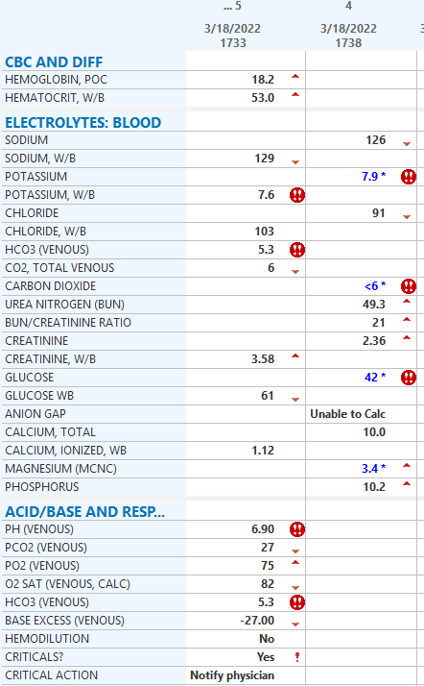
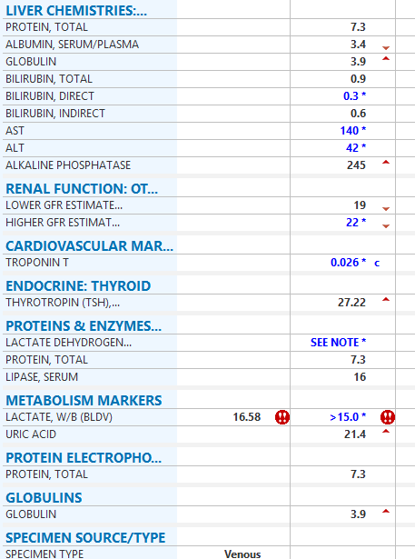

Imaging:
CXR showed ARDS

Plan after imaging and finding:
- Bicarb and calcium gluconate given due to high potassium
- BP continued to be too low for intubation, Norepinephrine at max 40 micrograms/min IV and the decision was made to place a central line in the internal jugular where she continued to received NE at max dose
- Patient continued to decline and eventually arrested that evening due to complications from hyperkalemia
  - The proposed reasoning for this was Tumor Lysis Syndrome from her underlying leukemia/lymphoma

These were the EKG tracings in her last minutes of death with the classic findings of death from hyperkalemia
